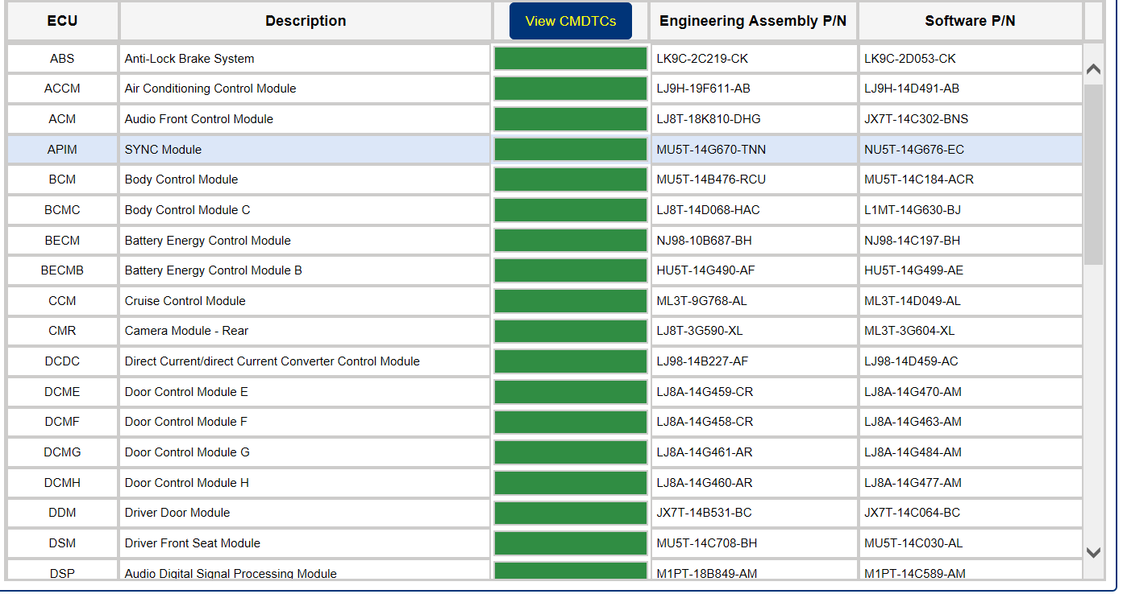
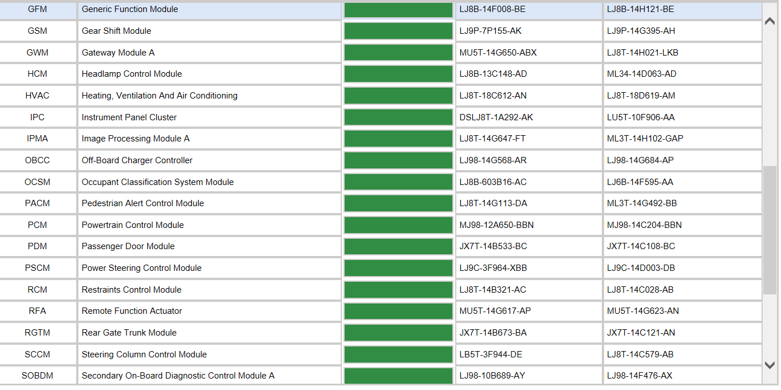
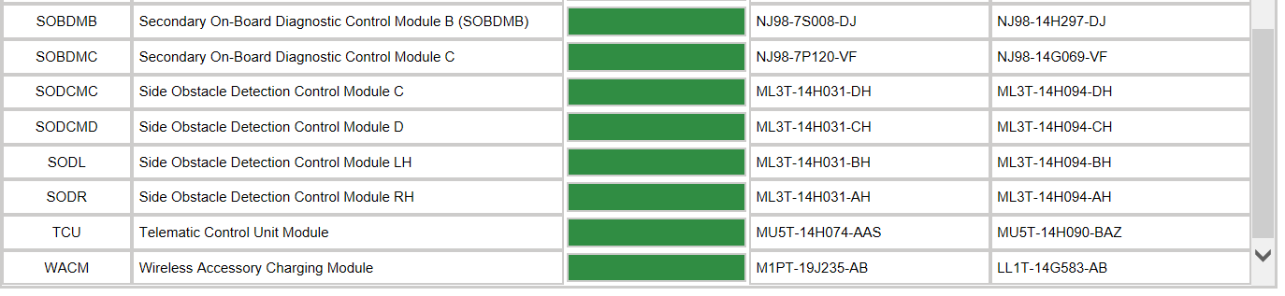
Programming 05/12/2023, 35 Total Mins, PCM, SOBDMB, BECM (FAILED ONCE), ABS. PCM still on list won’t clear! Tried it again and failed with message, won’t clear!

